This instruction summarize from <https://guides.github.com/introduction/flow/>.

This document containing explanation about flow for team development in this company:

Here the main capture flow:

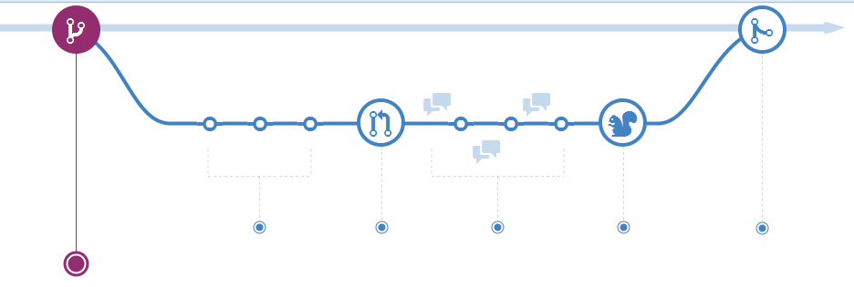

There are 5 points of steps that implement:

1. Create a branch

This branch is as lab in our project. So if we want to make new feature or any kind of changes in our project don’t effects master project.

**Pro Tip**

If we want to make new branch we will make name which describe the changes. our branch name should be descriptive (e.g., refactor-authentication, user-content-cache-key, make-retina-avatars), so that others can see what is being worked on.

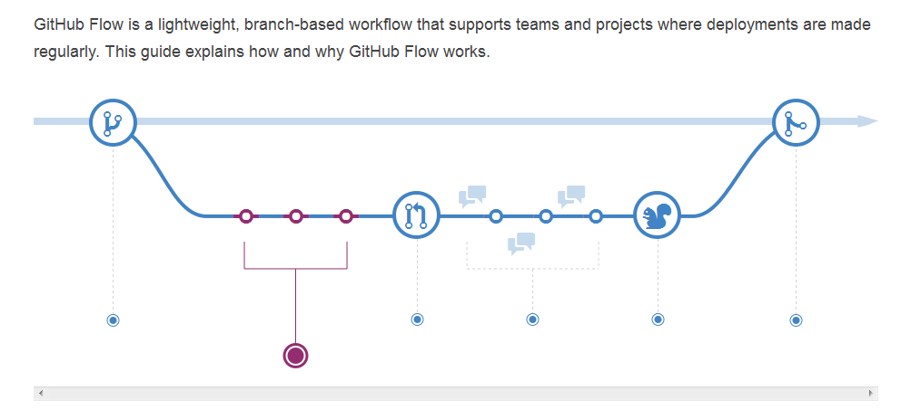

1. Add commits

Once your branch has been created, it’s time to start making changes. Whenever you add,edit, or deleted a file, you’re making a commit, and adding them to your branch. This process of adding commits keeps track of your progress as you work on a feature branch.

**ProTip**

Commit message are important, especia